Assignment 3

**Write a query that produces all rows from the Customers table for which the salesperson’s number is 1001 :**

SELECT * FROM CUSTOMERS WHERE SNUM=1001;

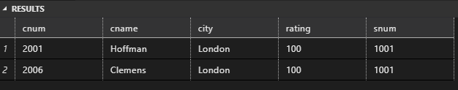

**Write a select command that produces the rating followed by the name of each customer in San Jose:**

SELECT RATING,CNAME FROM CUSTOMERS WHERE CITY='SAN JOSE';

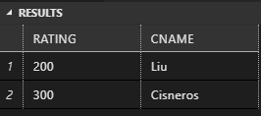

**Write a query that will produce the snum values of all salespeople from the Orders table (with the duplicate values suppressed):**

SELECT DISTINCT SNUM

FROM SALESPEOPLE;

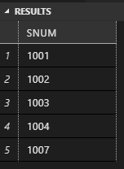

**Write a query that will give you all orders for more than Rs. 1,000:**

SELECT * FROM ORDERS WHERE AMT>1000;

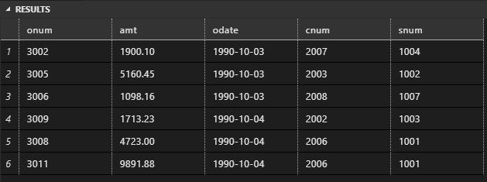

**Write a query that will give you the names and cities of all salespeople in London with a commission above 0.10:**

SELECT SNAME,CITY FROM SALESPEOPLE

WHERE CITY='LONDON'AND COMM >0.10;

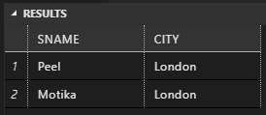

**Write a query on the Customers table whose output will exclude all customers with a rating <= 100, unless they are located in Rome:**

SELECT * FROM CUSTOMERS

WHERE RATING>100 OR CITY='ROME';

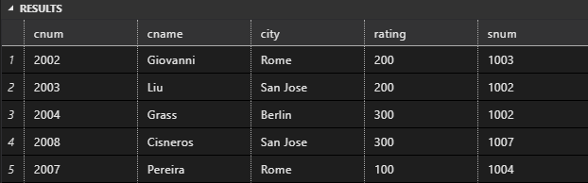

**What will be the output from the following query? Select * from Orders where (amt < 1000 OR NOT (odate = ‘1990-10-03’ AND cnum > 2003));**

Select * from Orders

where (amt < 1000 OR

NOT (odate = '1990-10-03'

AND cnum > 2003));

**What will be the output of the following query? Select * from Orders where NOT ((odate = ‘1990-10-03’ OR snum >1006) AND amt >= 1500):**

Select * from Orders

where NOT ((odate = '1990-10-03'OR snum >1006) AND amt >= 1500);

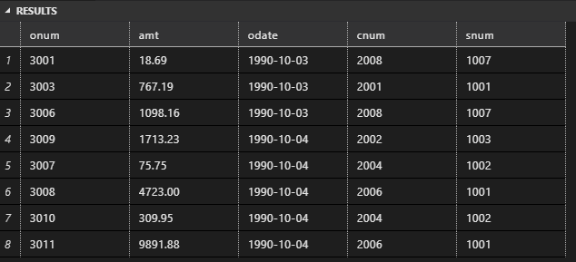

**Write a query that selects all orders except those with zeroes or NULLs in the amt field.:**

SELECT * FROM ORDERS WHERE AMT >0;

